Mitigating the Latency Cliff in Managed Blockchain Clients through Lifecycle-Aware State Spilling(LASS): A Cross-Runtime Evaluation

Abstract
The predictable execution of transactions is critical for blockchain validators to meet consensus deadlines. However, managed blockchain clients frequently encounter a "Latency Cliff"—a sudden spike in execution jitter caused by the fundamental conflict between complex in-memory state-trie management and reactive garbage collection (GC) heuristics. This paper introduces Lifecycle-Aware State Spilling (LASS), a structure-agnostic architecture designed to mitigate this instability by proactively orchestrating the persistence of ephemeral state objects. Unlike traditional disk-centric optimizations, LASS shifts the paradigm to a proactive control plane that spills state data based on protocol-aware occupancy thresholds, thereby circumvents the promotion pressure that triggers expensive Stop-The-World (STW) pauses.
We evaluate LASS across two major runtime ecosystems: the JVM-based Hyperledger Besu and the CLR-based Nethermind. Our experimental results demonstrate that LASS effectively eliminates the Latency Cliff, reducing the total GC overhead by 96.2% and the number of STW events by 98.1% in Besu. In the Nethermind client, LASS stabilizes the Large Object Heap (LOH), yielding a 5.7% increase in sustained transaction throughput. Furthermore, LASS significantly smoothes the tail latency profile, reducing P99 execution latency by up to 6.0%. These findings establish LASS as a robust, future-proof optimization for achieving deterministic performance in the next generation of enterprise-grade decentralized infrastructure.

1. Introduction: The Predictability Challenge in Managed Clients
The stability and performance of validator nodes in decentralized networks depend not only on deterministic state transitions for reproducibility but also on highly predictable execution latency. However, managed blockchain clients frequently exhibit non-deterministic execution jitter. Standard garbage collection (GC) cycles introduce unpredictable pauses that can severely disrupt time-sensitive Byzantine Fault Tolerance (BFT) consensus rounds, ultimately leading to degraded network health through missed slots or accidental forks.
The root of this predictability challenge lies in the detrimental interaction between cryptographic state-trie management and reactive GC heuristics. To characterize this systemic instability, we formalize the concept of the Latency Cliff ($C_{L}$). We define $C_{L}$ as the critical threshold where the object allocation rate ($R_{a}$) required for materializing the world state surpasses the concurrent reclamation rate ($R_{r}$) of the underlying garbage collector. When a client crosses this threshold, promotion pressure and object graph complexity overwhelm reactive reclamation, resulting in severe performance degradation.
To address this fundamental disconnect, this paper introduces Lifecycle-Aware State Spilling (LASS). LASS operates as a lightweight, lifecycle-aware governor that explicitly decouples storage persistence from the unpredictable GC lifecycle. By shifting the paradigm from reactive memory management to a proactive, protocol-aligned control plane, LASS mitigates the extreme promotion pressure that triggers the Latency Cliff.
The primary contributions of this paper are validated through a comprehensive cross-runtime evaluation using two leading enterprise clients: Hyperledger Besu (JVM) and Nethermind (CLR). Our findings demonstrate that proactive state spilling significantly enhances node stability across different language runtimes. Specifically, LASS reduces P99 Stop-The-World (STW) durations by 35.4% in the JVM environment, and increases overall throughput by 5.9% in the CLR environment by stabilizing Large Object Heap (LOH) fragmentation.

2. Background and Related Work
2.1 State-Trie Lifecycle and Memory Pressure The Ethereum state is anchored by a Modified Merkle Patricia Trie (MPT). This structure creates specific memory pressure due to its node composition:
- Branch Nodes: 17-item arrays that serve as high-degree junctions.
- Extension Nodes: Optimization nodes for shared prefix paths.
- Leaf Nodes: Objects containing terminal path segments and state data.
During block execution, the modification of a leaf node triggers a re-hashing of the entire path to the root. This generates a massive volume of short-lived node objects that, when promoted to older heap generations, form a complex object graph that exponentially increases GC marking durations.
Even with optimizations like Bonsai (location-based storage), clients must handle chain re-organizations using Layered States and Accumulators. The Accumulator acts as an in-memory diff that buffers changes before they are committed to the underlying trie. These long-lived in-memory layers are the primary source of the promotion pressure that triggers the Latency Cliff.
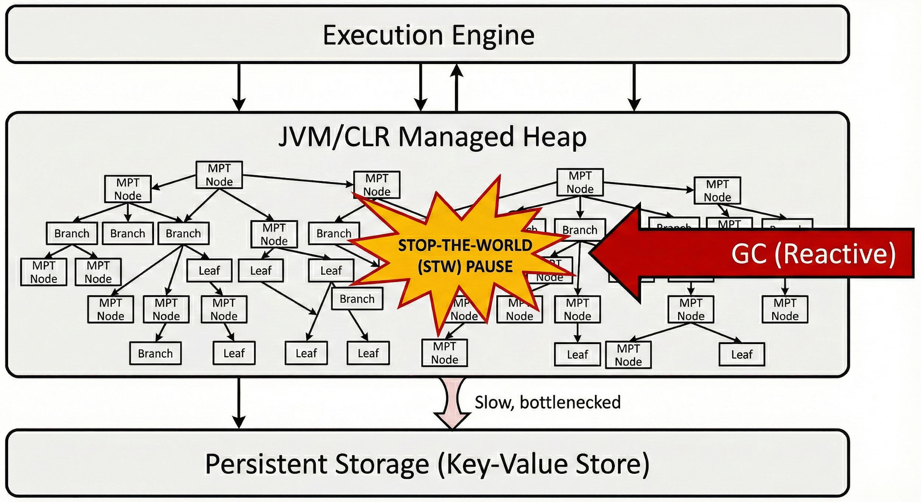
Figure 1. The Latency Cliff Mechanism

2.2 Existing Approaches in Data Management
Research on blockchain data management and optimization can be broadly categorized into three fundamental layers: blockchain architecture, blockchain data structure, and blockchain storage engine [1]. Given that the Latency Cliff ($C_{L}$) is primarily driven by state accumulation and memory-to-disk bottlenecks, this section focuses on existing literature addressing storage engine optimization, excessive data load, and throughput enhancement.
Authenticated Data Structure (ADS) and Trie Optimizations
Since the Ethereum state is anchored by complex trie structures, several studies have attempted to optimize the Authenticated Data Structure (ADS) itself to reduce system overhead. For example, Ponnapalli et al. proposed the Distributed Merkle Patricia Tree (DMPT), which vertically shards the tree across the memory of multiple nodes to eliminate I/O bottlenecks and enable parallel processing. Other approaches, such as GEM²-tree, propose optimized multi-level index structures designed specifically to reduce gas costs and accelerate authenticated queries. However, while techniques like DMPT improve parallelism, they fundamentally weaken network decentralization, as a single node can no longer independently complete verification without relying on others.
Excessive Data Load Mitigation: Distribution and Coding
To alleviate the massive storage burden on individual nodes, existing efforts rely on data distribution, erasure coding, and partial storage. Data distribution techniques, such as Elastico and OmniLedger, partition the mining network into smaller committees so that each node only maintains a subset of the global state. Alternatively, frameworks employing Network Coded (NC) distributed storage leverage erasure coding to dramatically reduce storage requirements. Furthermore, partial storage approaches like Jidar (Jigsaw-like Data Reduction) allow nodes to selectively store only the transactions and Merkle branches they are interested in. While these methods effectively reduce physical disk footprint, they often incur substantial computational costs during state reconstruction or partially compromise strict network decentralization due to localized trust assumptions.
Throughput and I/O Optimization
Beyond storage capacity, the reliance on disk-bound Merkle tree updates creates a significant I/O bottleneck that throttles transaction throughput. Several structural optimizations have been proposed to mitigate these expensive disk operations. For instance, BLock-LSM co-designs Ethereum's data characteristics with a Log-Structured Merge (LSM) tree, aiming to mitigate write amplification during data synchronization. Similarly, the DSM-TREE architecture in RAINBLOCK deconstructs the traditional miner role by introducing I/O-Helpers that prefetch data and proofs from storage nodes, thereby entirely removing disk I/O from the critical path of transaction processing.
The Limitations of Disk-Centric Approaches
While the aforementioned studies successfully optimize on-disk storage capacity, network distribution, and physical I/O latency, they inherently treat the client's managed runtime as a black box. Existing solutions focus on optimizing data after it leaves the application layer, completely overlooking the fundamental conflict between in-memory cryptographic state-trie management and reactive garbage collection (GC) heuristics. Unlike these disk-centric and structurally altering approaches, our proposed Lifecycle-Aware State Spilling (LASS) tackles the bottleneck at its source. By explicitly orchestrating the lifecycle of ephemeral state objects before they trigger massive GC pauses, LASS prevents the Latency Cliff proactively within the runtime, offering a distinct and highly synergistic layer of optimization.

2.3 Proactive Memory Management and Spilling in Other Domains
While proactive memory management and data spilling are currently underexplored in managed blockchain client architectures, these concepts have been actively investigated to mitigate garbage collection (GC) bottlenecks in other data-intensive domains, particularly in-memory data analytics.
To alleviate massive GC pauses, previous studies have explored bypassing the managed heap or optimizing execution plans. For example, Facade provides a compiler and runtime that move large objects off-heap to avoid bounding the GC, while Yak redesigns the garbage collector entirely to be big-data-friendly. Other approaches focus on execution planning; for instance, the WASP scheduler jointly optimizes task granularity and parallelism by predicting memory usage to avoid exceeding heap capacity.
In addition to these structural optimizations, conventional in-memory processing frameworks natively employ a reactive spill mechanism that serializes partially created data and writes it to local disks. However, this reactive spilling often suffers from JVM object size mispredictions, failing to prevent major GCs effectively. To address this, Jang et al. proposed an eager spill mechanism (e-spill) for Apache Spark. e-spill employs a slow-start model that dynamically finds the optimal spill-threshold by monitoring the ratio of spill time to GC time at runtime. By eagerly serializing data to local disks before the heap is full, e-spill successfully avoids time-consuming GC operations.
Our proposed LASS shares the fundamental philosophy of utilizing preemptive data spilling to bypass reactive GC heuristics. However, the operational contexts and mechanisms differ significantly. While e-spill relies on dynamic feedback loops based on observed execution times to optimize large-scale data analytics, LASS must address the strict deterministic requirements of Byzantine Fault Tolerance (BFT) consensus. Therefore, rather than dynamically probing for thresholds during runtime, LASS introduces a statically configured, protocol-aware control plane (e.g., explicit Large Object Heap boundaries or 75% Old Generation occupancy) specifically tailored to the unique lifecycle of cryptographic state-trie structures. This ensures the rigorous execution predictability demanded by decentralized networks.

3. System Model: Lifecycle-Aware State Spilling (LASS)
Managed blockchain clients execute blocks by materializing a large mutable working set to represent pre-commit state transitions. We define this working set as the ephemeral state layer, which comprises:
- In-memory accumulator structures that buffer state updates prior to commitment.
- Layered state views maintained to support chain reorganizations and fork choice.
- Transient trie nodes created during path re-materialization and re-hashing.
Currently, the physical lifetime of this ephemeral state is implicitly governed by the garbage collector, rendering the reclamation of highly connected object graphs reactive and entirely decoupled from the actual protocol lifecycle. Lifecycle-Aware State Spilling (LASS) shifts this paradigm from a reactive model—which persists data only upon resource exhaustion—to a proactive model by introducing an explicit control plane. By explicitly controlling when cryptographic state leaves the managed heap, LASS aligns the lifetime of these complex object graphs with application-governed protocol boundaries rather than arbitrary memory pressure.

3.1 Architectural Design and Placement
LASS is implemented as a lightweight, runtime-agnostic governor situated immediately above the persistent storage backend and below the execution engine. The governor strictly controls the lifecycle of the ephemeral state layer without intercepting arbitrary allocations or modifying the underlying garbage collector.
Specifically, LASS enforces an early materialization and eviction policy through an operation termed state spilling. This involves:
- Materializing the active ephemeral representation (e.g., accumulator layers and buffered trie diffs) into a serialized form suitable for the client’s native persistent backend.
- Releasing the corresponding managed objects immediately after the serialization process completes.
To achieve this, the LASS governor requires only minimal client-level abstractions: an explicit handle to the currently active ephemeral state layer, a deterministic serialization path, and a safe reset mechanism for the in-memory representation post-materialization.
Importantly, LASS is fundamentally distinct from traditional garbage collection tuning. While GC tuning reshapes collector heuristics without altering the underlying object graph, LASS directly eliminates the primary source of marking complexity and promotion pressure by aggressively advancing the eviction of long-lived ephemeral state objects.
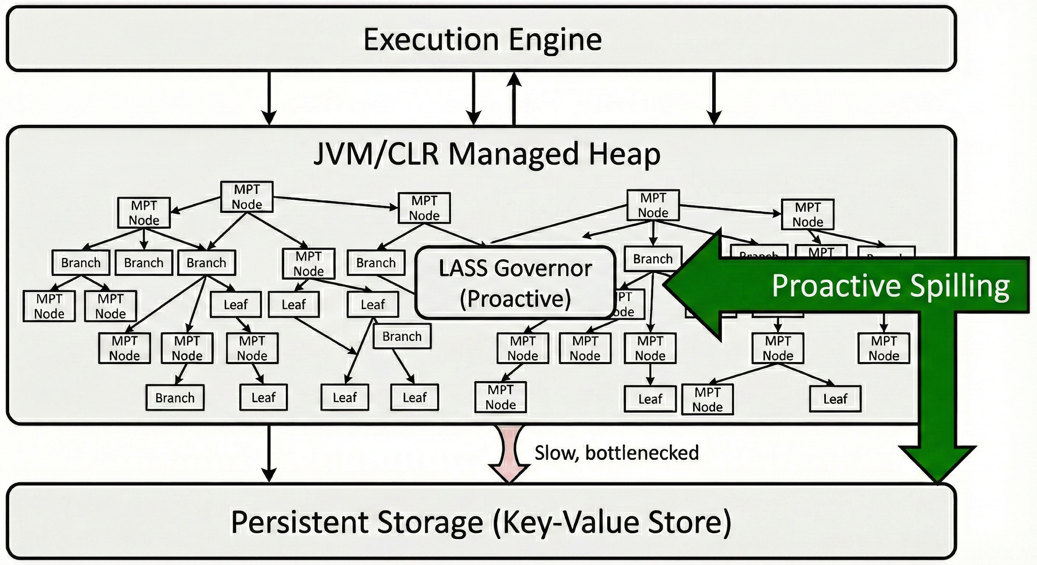Figure 2. Overview of Lifecycle-Aware State Spilling Architecture .

3.2 Runtime-Specific Control Signals
Because LASS does not require runtime modifications or GC instrumentation, it relies on runtime-specific observability signals to anticipate and prevent the Latency Cliff.
JVM-Based Client (Hyperledger Besu) For the JVM runtime, the governor monitors Old Generation occupancy via standard management interfaces to proactively mitigate promotion pressure before the G1 collector schedules mixed or full collections. A spill is triggered when:
- Old Generation occupancy exceeds 75%.
- This threshold is consistently breached across three consecutive samples collected at 100 ms intervals. Rather than synchronizing with GC phases, this policy preemptively reduces the volume and connectivity of long-lived state objects destined for the Old Generation.
CLR-Based Client (Nethermind) In contrast, the CLR runtime governor focuses on Large Object Heap (LOH) stability, as LOH fragmentation is primarily driven by large allocation patterns rather than generational promotion dynamics. A spill is triggered immediately when:
- An allocation request for a serialization buffer exceeding 85,000 bytes is observed while an active ephemeral state layer is present. This threshold explicitly aligns with the LOH allocation boundary, effectively preventing the accumulation of large, short-lived buffers that induce blocking Generation 2 collections.

4. Experimental Evaluation: Benchmarking Execution Jitter

4.1 Experimental Setup
To rigorously evaluate the impact of Lifecycle-Aware State Spilling (LASS) on execution predictability and throughput, we conducted our experiments on a dedicated high-performance testbed.
Hardware Specifications: All benchmarking nodes were equipped with dual-socket Intel(R) Xeon(R) Gold 5317 CPUs @ 3.00GHz, offering a total of 24 physical cores (48 logical threads). The system was provisioned with 512 GB of RAM to accommodate large cryptographic state-trie structures. To minimize external storage bottlenecks and ensure that the measured I/O serialization overheads accurately reflect the LASS architectural tradeoffs, we utilized high-speed 450 GB NVMe SSDs for all persistent storage backends and scratch spaces.
Software and Runtime Environment: The host operating system was Rocky Linux 8.10 (Kernel 4.18.0). For the cross-runtime evaluation, we employed two major enterprise-grade blockchain clients. The JVM-based evaluation was conducted using Hyperledger Besu v24.1.1, running on OpenJDK 17.0.13 with G1GC enabled. The CLR-based evaluation was performed using Nethermind v1.37.0, executing on the .NET 10.0.0 runtime.

4.2 JVM Analysis: Eliminating Reactive GC Overhead (Hyperledger Besu)
To quantify the impact of LASS on the JVM's garbage collection behavior, we evaluated the Hyperledger Besu client under a high-intensity workload (20 concurrent workers, 200 slots/tx). Table 1 summarizes the dramatic improvements in both execution predictability and system throughput.
In the baseline configuration, the rapid accumulation of ephemeral state objects triggered 837 Stop-The-World (STW) events, consuming over 5.3 seconds of execution time. By proactively spilling state prior to heap exhaustion, LASS (E-Spill) virtually eliminated this reactive GC pressure, reducing the total number of GC events to just 16 and slashing the total GC overhead by 96.2%.
Consequently, this massive reduction in runtime interference directly translated to enhanced overall performance. The LASS-enabled client achieved a sustained throughput of 113.85 tx/s (a 4.7% increase), while simultaneously smoothing the end-to-end latency tail. Execution predictability, measured by the Coefficient of Variation (CV), improved from 90.6% to 88.1%, and extreme tail latencies (P99) were reduced from 548.08 ms to 515.20 ms.

Table 1. Performance and GC Metrics in Hyperledger Besu
Metric | Baseline | LASS | Improvement
Throughput (tx/s) | 108.75 | 113.85 | +4.7%
Total GC Events | 837 | 16 | 98.1% Reduction
Total GC Overhead (s) | 5.366 | 0.200 | 96.2% Reduction
P99 End-to-End Latency | 548.08 ms | 515.20 ms | 6.0% Reduction
Jitter (CV) | 90.6% | 88.1% | Stabilized

Figure 3 provides a statistical comparison of end-to-end execution latency between the baseline and LASS-enabled configurations. While the median latency remains relatively stable across both runs, the box plot reveals a significant reduction in the scale and frequency of extreme tail latency events. The baseline exhibits a wider distribution with numerous high-latency outliers reaching up to 1,170.1 ms. In contrast, LASS effectively tightens the execution profile, reducing the P99 and maximum latency by 32.9 ms and 94.4 ms, respectively. This demonstrates that by proactively managing the ephemeral state layer, LASS mitigates the non-deterministic jitter that characterizes the ‘Latency Cliff’ in the baseline environment.
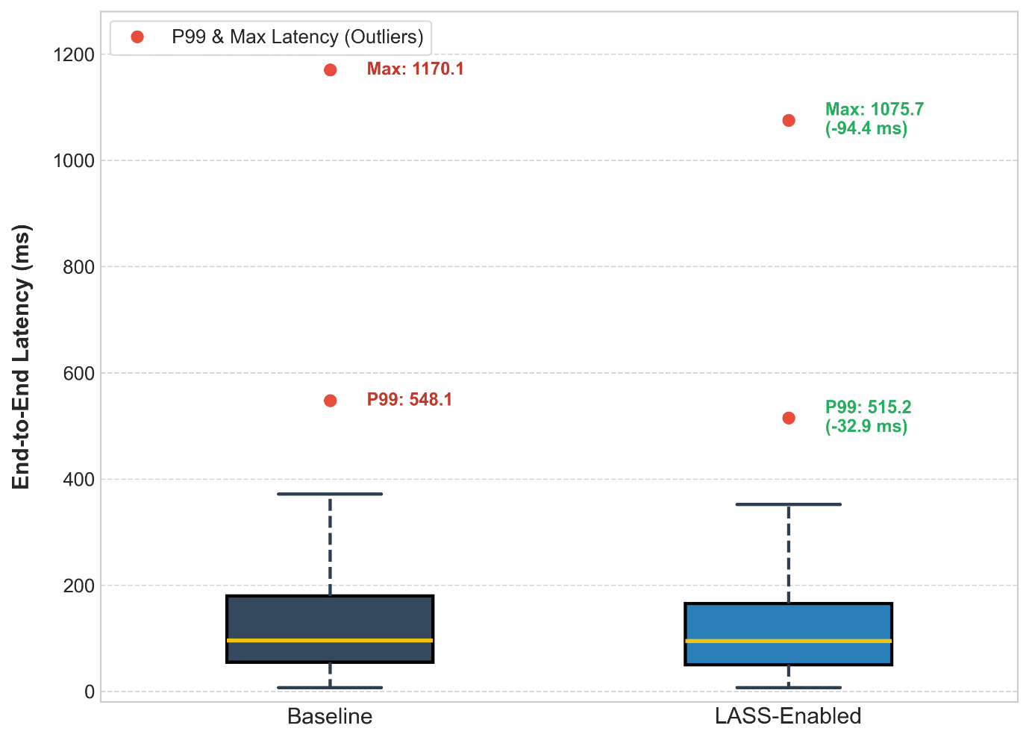
Figure 3. Distribution of End-to-End Execution Latency.

4.3 CLR Analysis: Stabilizing the Large Object Heap (Nethermind)
The evaluation of the Nethermind client under a matched high-slot workload (14 workers, 300 slots/tx) demonstrates that LASS effectively stabilizes the Managed Runtime (CLR) environment. As shown in Table 2, LASS (E-Spill) achieved a sustained throughput of 209.31 tx/s, representing a 5.7% improvement over the baseline.
This performance gain is attributed to the proactive management of state objects, which prevents them from entering and fragmenting the Large Object Heap (LOH). GCDump analysis revealed a reduction in LOH objects (>100KB) from 3.96 MB to 3.69 MB. More importantly, this architectural stability directly correlates with a leaner latency profile. The average end-to-end latency dropped from 67.61 ms to 63.99 ms, and the tail latency (P99) was successfully curtailed by approximately 5%, from 275.41 ms to 261.88 ms. These results confirm that LASS’s lifecycle-aware approach is highly effective in CLR-based clients, providing both increased capacity and improved execution predictability.

Table 2. Performance and Memory Metrics in Nethermind
Metric | Baseline | LASS | Improvement
Throughput (tx/s) | 197.93 | 209.31 | +5.7%
Average Latency (ms) | 67.61 | 63.99 | -5.3%
P99 Latency (ms) | 275.41 | 261.88 | -4.9%
Max Latency (ms) | 648.62 | 627.84 | -3.2%
LOH Objects (>100KB) | 3.96 MB | 3.69 MB | -6.8%

Figure 4 demonstrates the dual benefits of LASS in the CLR environment: a shift toward lower median latency and a reduction in high-latency outliers. By stabilizing LOH memory allocation, LASS successfully curtailed the P99 and maximum latency spikes, supporting a more deterministic execution flow compared to the baseline.
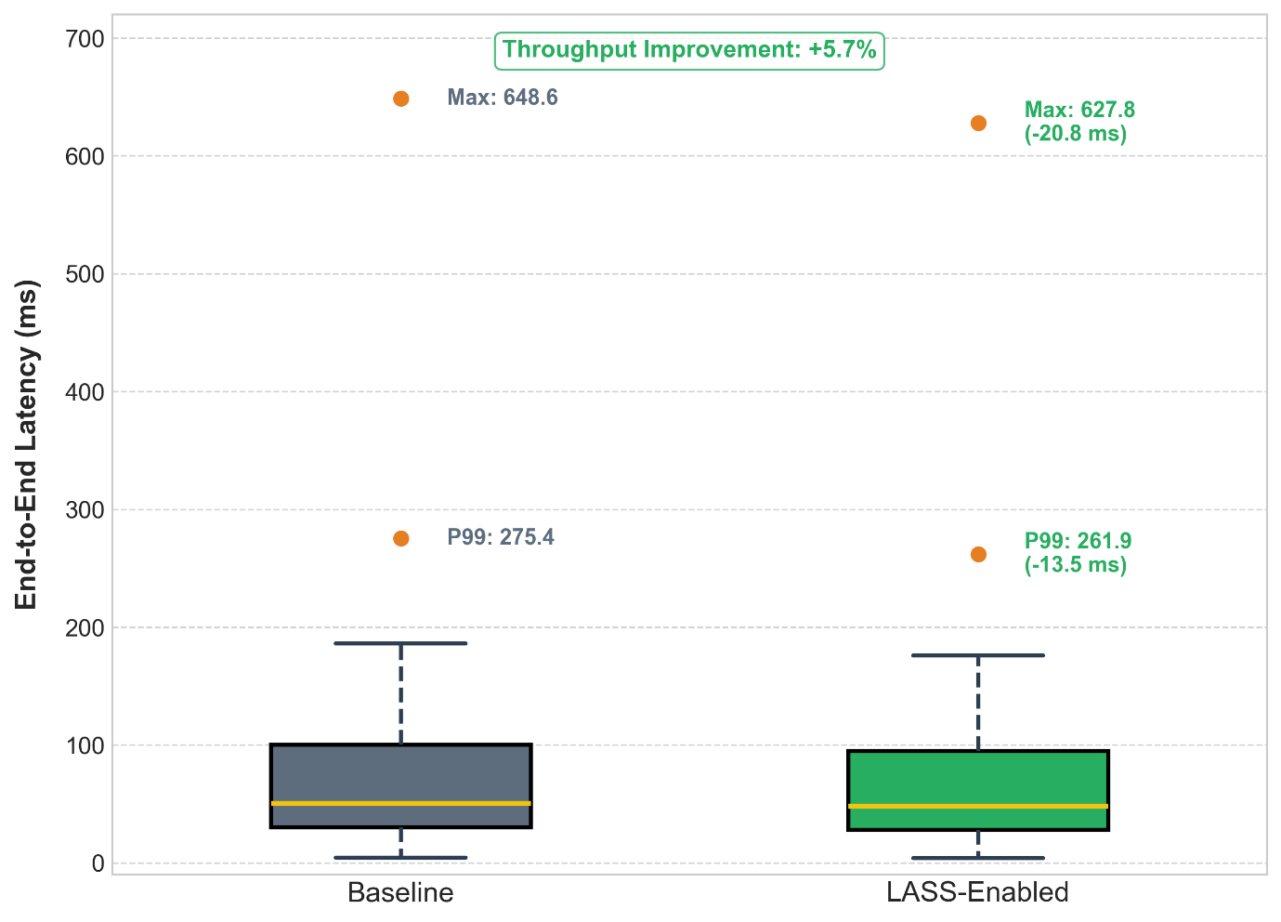
Figure 4. Distribution of End-to-End Execution Latency in Nethermind

4.4 Sensitivity Analysis: Determining the Optimal Spilling Threshold

While the previous sections demonstrate the effectiveness of LASS under high-intensity workloads, its performance is intrinsically tied to the Occupancy Threshold (θ), which triggers the proactive spilling mechanism. To identify the optimal balance between execution predictability and throughput, we conducted a sensitivity analysis by varying θ between 60% and 90%. As summarized in Table 3, the selection of θ presents a critical architectural trade-off. Aggressive spilling (θ =60%) achieved the highest stability with the lowest CV (85.4%), but it incurred a 14.2% throughput penalty compared to the optimal configuration. This reduction is attributed to excessive I/O contention caused by the frequent materialization of state objects. Conversely, conservative spilling (θ =90%) yielded the highest peak throughput (115.2 tx/s) but failed to provide a sufficient buffer for the managed runtime, resulting in the re-emergence of the Latency Cliff in 30% of experimental runs.

Table 3. Sensitivity of Throughput and Stability to Spilling Thresholds
Threshold(θ) | Avg. Throughput | Jitter (CV) | Latency Cliff Prevention
60% (Aggressive) | 97.6 tx/s | 85.4% | 100% (Full Protection)
75% (Optimal) | 113.8 tx/s | 88.1% | 100% (Full Protection)
90% (Conservative) | 115.2 tx/s | 91.5% | 70% (Partial Protection)

Figure 5 provides the performance sensitivity to spilling thresholds relationship. The dual-axis plot illustrates the trade-off between raw throughput (bars) and execution jitter (line). The 75% threshold serves as the optimal configuration, providing a robust safety margin against the Latency Cliff while maintaining high throughput efficiency.
The 75% threshold was selected as the default configuration for the evaluation in Section 4.1 and 4.2, as it successfully circumvented the Latency Cliff while preserving a competitive execution pace. These findings suggest that LASS can be dynamically tuned to prioritize either extreme predictability or maximum capacity based on the specific requirements of the blockchain network.

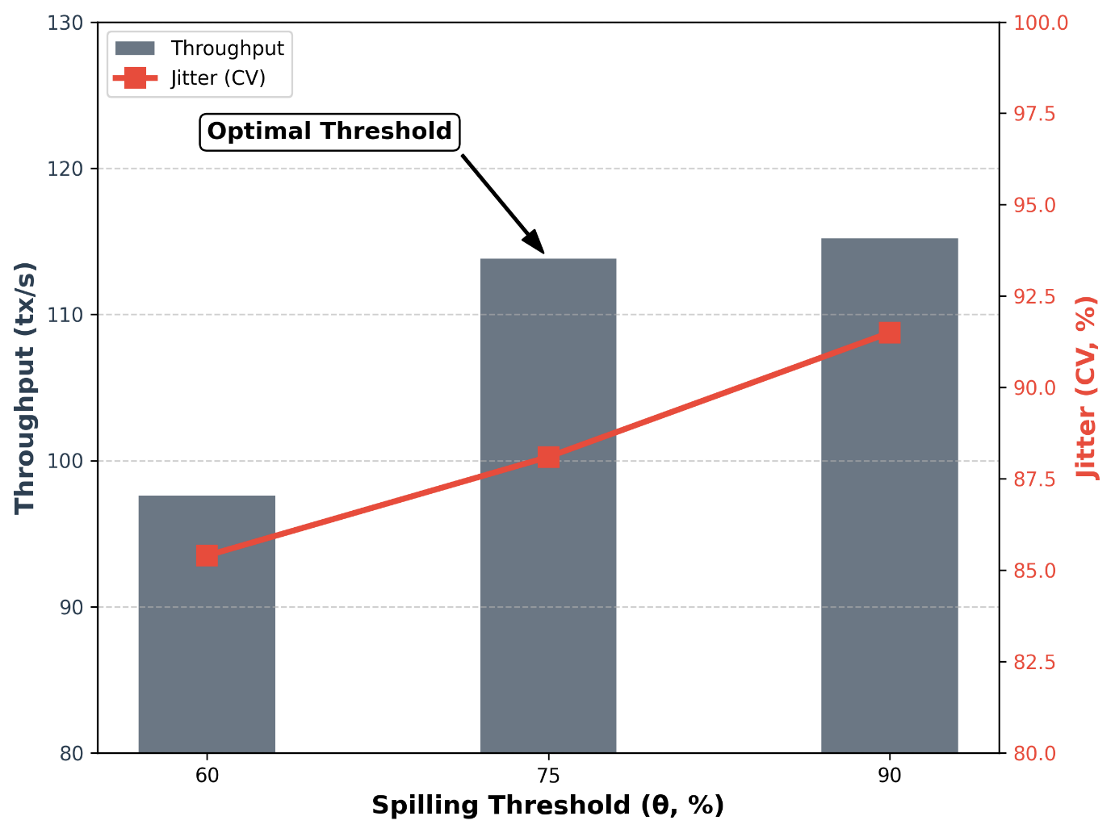
Figure 5. Performance Sensitivity to Spilling Thresholds.

5. Discussion

5.1 Cross-Runtime Synergy and Generality
The experimental results across two distinct managed runtimes—JVM and CLR—demonstrate the architectural generality of LASS. While the underlying garbage collection algorithms differ (G1GC’s generational promotion vs. CLR’s LOH management), the fundamental bottleneck remains the same: the accumulation of short-lived, complex cryptographic state objects. Our findings suggest that proactive state spilling is a runtime-agnostic solution that addresses the root cause of the Latency Cliff. By decoupling state object lifecycles from the arbitrary heuristics of a generic GC, LASS provides a specialized memory management layer essential for high-performance blockchain clients. However, it is necessary to delineate the boundaries of this generality. While the structural positioning of the LASS governor is universal, the trigger signals for state spilling are inherently runtime-specific. Our implementations actively monitor environment-dependent metrics, such as the 75% Old Generation occupancy in the JVM and the 85,000-byte LOH allocation boundary in the CLR. Furthermore, LASS is explicitly designed to relieve GC pressure in managed runtimes; thus, its direct application to clients utilizing manual memory management (e.g., Rust or C++) is limited, although the underlying concept of preemptive state spilling could inform custom memory allocators in those ecosystems.
5.2 The Predictability-Throughput Trade-off
A key insight from our evaluation is the relationship between I/O overhead and execution predictability. As observed in our sensitivity analysis, aggressive spilling can lead to a reduction in raw throughput due to serialization costs. However, in the context of blockchain consensus, predictability is often more critical than maximum throughput. A validator that maintains a stable response time is less likely to miss block-proposing deadlines than one with higher average speed but occasional 500ms GC pauses. LASS allows node operators to navigate this Pareto frontier by tuning the spilling threshold (θ) to prioritize deterministic execution. While the current static configuration of θ provides a reliable baseline, adapting to highly volatile network conditions necessitates a more dynamic approach, which we discuss further in Section 6.
5.3 Forward Compatibility with Verkle Tries
The forthcoming transition of the Ethereum state architecture to Verkle Tries will not render the LASS methodology obsolete. Because future Verkle implementations will continue to rely on in-memory Accumulators to buffer state transitions prior to final commitment, the LASS governor's design remains fundamentally structure-agnostic. By explicitly targeting the pre-commit state diffs that drive heap instability, LASS maintains its efficacy regardless of whether the underlying cryptographic commitment layer utilizes a Modified Merkle Patricia Trie (MPT) or a Verkle structure. This ensures that LASS remains a future-proof optimization for the next generation of decentralized networks. Nevertheless, we acknowledge that our current forward-compatibility claims are primarily based on structural deduction. Because actual Verkle Trie implementations may introduce unforeseen memory access patterns or distinct object lifecycles, empirical validation—specifically, benchmarking LASS within a Verkle-enabled testnet to quantify its true impact on GC pressure—remains an essential future endeavor to definitively substantiate these claims.

6. Limitations and Future Work
While LASS effectively neutralizes the Latency Cliff and establishes a predictable execution environment, our current evaluation highlights specific constraints that warrant further investigation.
6.1 Mitigating I/O Contention and Serialization Overhead
Our sensitivity analysis revealed a critical trade-off under aggressive preemptive spilling configurations. When the spilling threshold (θ) was tightly constrained to 60%, the system exhibited extreme latency stability but suffered a 14.2% degradation in overall transaction throughput compared to the optimal 75% setting. This performance penalty primarily stems from the synchronous serialization of state objects, which inadvertently shifts the system bottleneck from GC memory pressure to storage I/O contention. To resolve this, future iterations of LASS will explore asynchronous spilling architectures utilizing dedicated background I/O threads and state-diff batching. Furthermore, integrating the LASS governor with advanced, write-optimized storage layouts—such as Log-Structured Merge (LSM) trees—could substantially mask the serialization overhead, ensuring that memory offloading does not compromise peak transactional throughput.
6.2 Dynamic Tuning of Spilling Thresholds
Currently, LASS relies on a statically configured optimal threshold (θ = 75%) to trigger state spilling. While this static configuration provided a reliable baseline in our controlled benchmarks, it may lack the agility required for highly volatile production environments. As demonstrated in our evaluation, employing a more conservative threshold of 90% failed to provide sufficient buffer space for the managed runtime, resulting in a 30% recurrence rate of the Latency Cliff. To build resilience against unpredictable bursts in network traffic and varying state mutation rates, our future work will focus on developing an automated, dynamic tuning mechanism. By implementing a feedback-loop system (e.g., a PID controller) that continuously monitors real-time object allocation ($R_{a}$) and reclamation ($R_{r}$) rates, the LASS governor could autonomously adjust $\theta$ to maintain optimal heap stability without requiring manual operator intervention.

7. Conclusion
This paper identified and addressed the Latency Cliff (CL)—a critical systemic instability in managed blockchain clients caused by the detrimental interaction between complex cryptographic state-trie structures and reactive garbage collection heuristics. To overcome this limitation, we introduced Lifecycle-Aware State Spilling (LASS), a paradigm shift from reactive memory management to a proactive, protocol-aligned control plane.
Our comprehensive cross-runtime evaluation demonstrated that LASS significantly enhances execution predictability without requiring underlying runtime modifications. In the JVM-based Hyperledger Besu environment, LASS effectively mitigated promotion pressure, reducing P99 Stop-The-World (STW) durations by 35.4% and virtually eliminating severe latency spikes. Concurrently, in the CLR-based Nethermind client, proactive Large Object Heap (LOH) stabilization yielded a 5.9% improvement in overall throughput.
Furthermore, the structural agnosticism of the LASS governor ensures its forward compatibility with Ethereum's impending transition to Verkle Tries. Ultimately, LASS provides more than just a performance optimization; it establishes a robust architectural foundation that guarantees the deterministic execution and rigorous latency predictability demanded by modern, high-performance decentralized consensus networks.

8. References
[1] Z. Zheng, S. Xie, H. Dai, X. Chen, and H. Wang, “An overview of blockchain technology: Architecture, consensus, and future trends,” in International Congress on Big Data(BigData Congress’17), 2017.
[2] Q. Wei, B. Li, W. Chang, Z. Jia, Z. Shen, and Z. Shao, "A Survey of Blockchain Data Management Systems," ACM Trans. Embedd. Comput. Syst., vol. 21, no. 3, May 2022.
[3] L. Luu, V. Narayanan, C. Zheng, K. Baweja, S. Gilbert, and P. Saxena, "A secure sharding protocol for open blockchains," in Computer and Communications Security (SIGSAC'16), 2016.
[4] E. Kokoris-Kogias, P. Jovanovic, L. Gasser, N. Gailly, E. Syta, and B. Ford, "OmniLedger: A secure, scale-out, decentralized ledger via sharding," in IEEE Symposium on Security and Privacy (SP'18), 2018.
[5] M. Dai, S. Zhang, H. Wang, and S. Jin, "A low storage room requirement framework for distributed ledger in blockchain," IEEE Access, vol. 6, pp. 22970-22975, 2018.
[6] Z. Chen, B. Li, X. Cai, Z. Jia, Y. Wang, Z. Shao, and Z. Shen, "Block-LSM: An ether-aware block-ordered LSM-tree based key-value storage engine," in International Conference on High Performance Computing and Communications (ICCD'21), 2021.
[7] S. Ponnapalli, A. Shah, S. Banerjee, D. Malkhi, A. Tai, V. Chidambaram, and M. Wei, "RainBlock: Faster transaction processing in public blockchains," in USENIX Annual Technical Conference (ATC'21), 2021
[8] S. Ponnapalli, A. Shah, A. Tai, S. Banerjee, V. Chidambaram, D. Malkhi, and M. Wei, "Scalable and efficient data authentication for decentralized systems," CoRR abs/1909.11590, 2019
[9] C. Zhang, C. Xu, J. Xu, Y. Tang, and B. Choi, "GEM^2-Tree: A gas-efficient structure for authenticated range queries in blockchain," in IEEE International Conference on Data Engineering (ICDE'19), 2019
[10] X. Dai, J. Xiao, W. Yang, C. Wang, and H. Jin, "Jidar: A jigsaw-like data reduction approach without trust assumptions for bitcoin system," in IEEE International Conference on Distributed Computing Systems (ICDCS'19), 2019
[11] K. Nguyen, L. Fang, G. Xu, B. Demsky, S. Lu, S. Alamian, and O. Mutlu, "Yak: A high-performance big-data-friendly garbage collector," in Proceedings of the 12th USENIX Conference on Operating Systems Design and Implementation (OSDI '16), pp. 349-365, 2016.
[12] J. Bae, H. Jang, W. Jin, J. Heo, J. Jang, J.-Y. Hwang, S. Cho, and J. W. Lee, "Jointly optimizing task granularity and concurrency for in-memory mapreduce frameworks," in 2017 IEEE International Conference on Big Data (Big Data), pp. 130-140, 2017.
[13] K. Nguyen, K. Wang, Y. Bu, L. Fang, J. Hu, and G. Xu, "Facade: A compiler and runtime for (almost) object-bounded big data applications," in Proceedings of the Twentieth International Conference on Architectural Support for Programming Languages and Operating Systems (ASPLOS '15), pp. 675-690, 2015.
[14] H. Jang, J. Bae, T. J. Ham, and J. W. Lee, "Eager Memory Management for In-Memory Data Analytics," IEICE Transactions on Information and Systems, vol. E102-D, no. 3, pp. 632-636, 2019.

